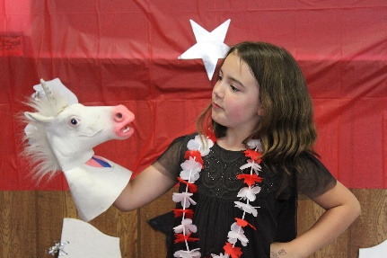
Our members wrapped up the year with their annual Awards Banquet and Potluck. Courtney and our Seniors did an amazing job organizing games and decorating. The favourite seemed to be the photo booth.
We recognized, and awarded, our skaters and volunteers for their hard work this season.
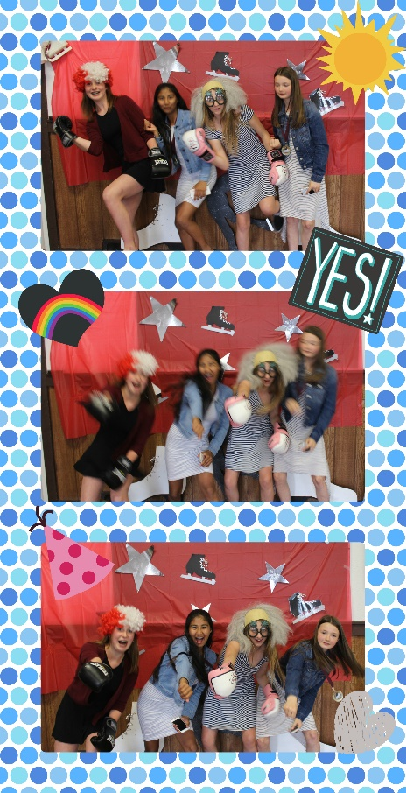
Most Improved CanSkate – Ty Longshaw
Skate Canada CanSkater of the Year – Olivia Vardy
CanSkate Certificate – Victoria Hoffman
Most Improved Star 1 – Stephanie Watts
Most Improved StarSkate – Frederick Prinsloo
Honorable Mention – Zoe Greze Kozuki
Most Improved Intermediate – Johanna Panas
Most Improved Senior – Mia Rosa
Most Improved Adult/Teen – Rene Prinsloo
Program Assistant of the Year – Heather Mudie
Senior Interpretative – Sierra Petrovcic
Junior Skills – Johanna Panas
Senior Skills – Celeste Gale
Jr Personal Success Achievement – Laure Minfray
Honorable Mention – Olivia Samuel
Intermediate Personal Success Achievement – Shanti Kellerhals
Senior Personal Success Achievement – Larissa Gedlaman
Sportsmanship – Heidi Schulte
Service Award – Marie Minfray, Registrar
Fundraising Award – Cara Latrace, Fundraising Director
StarSkate 2/3 Friendship – Emily Deering
Intermediate/Senior Friendship – Heidi Schulte and Johanna Panas
Graduating Skaters – Heather Mudie, Julia Bowles, Megan Weber
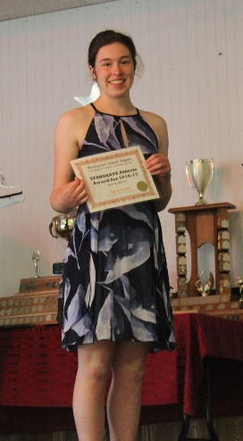
Special recognition is given to Andrea Beattie who was awarded the BC/YT StarSkater of the Year.
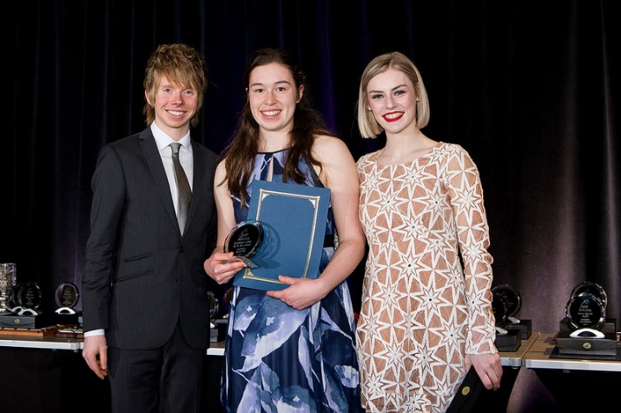

Congratulations!!!

